**Project Name :Hotel.Now**( Hotel Booking website)

**Overview :**

HotelNow is hotel booking website that enables travelers to Nigeria book hotels easily before they arrive.

With **Hotel.Now** you can find hotels by categories which include affordable hotels, hotel room types, hotel locations and by hotel facilities.

This will be my second project in the Full Stack Web Development Internship program with Edureka.

**Home Page:**

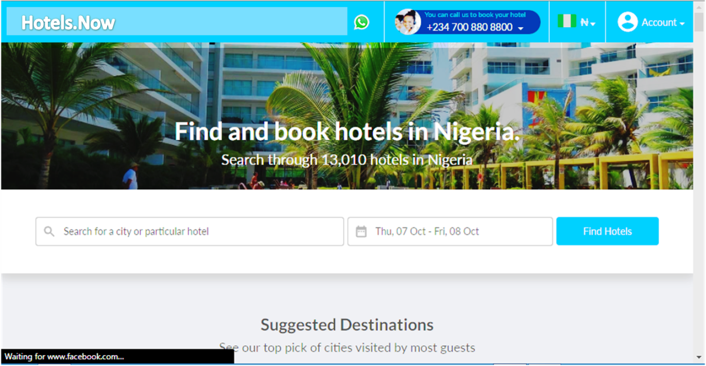

**Details Page:**

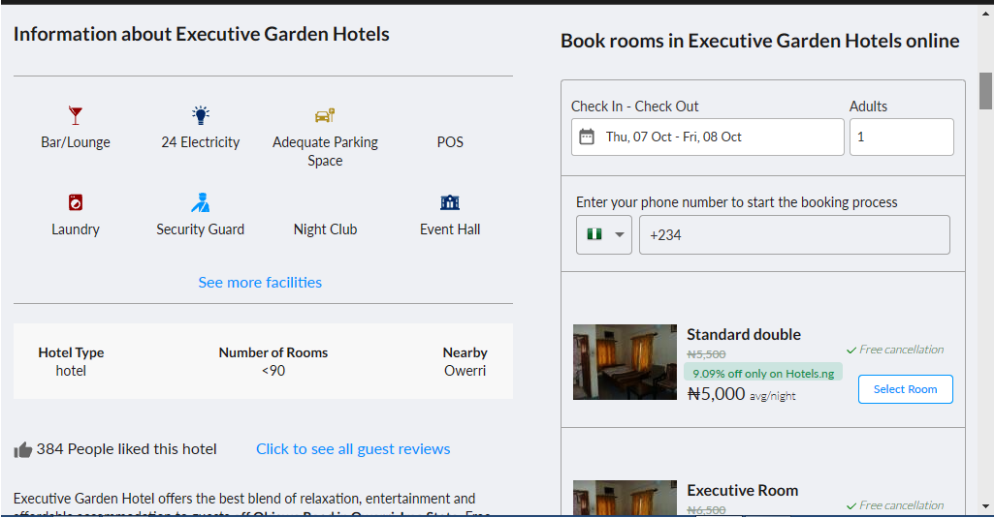

**Information Page:**

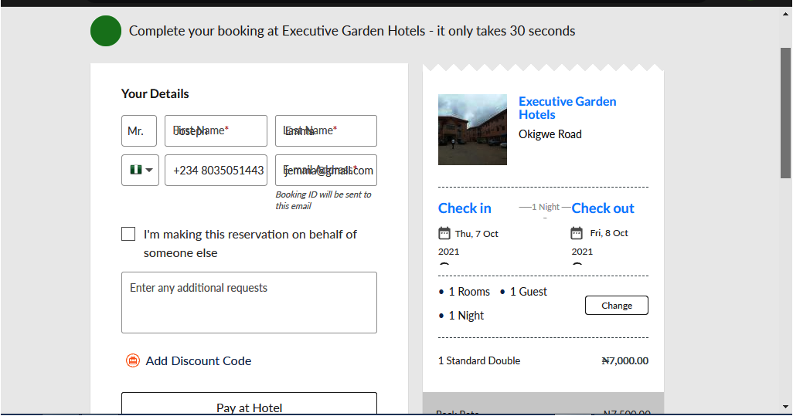

**Payment/CheckOut Page:**

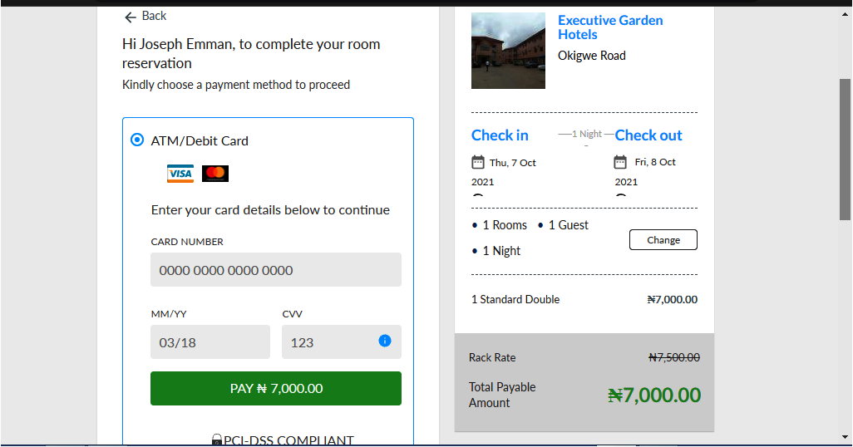

**Other Pages include Dynamic Search Pages and Login/Registration Pages.**

**Technology Used:**

Front-End:

1. Html
2. Css
3. Bootstrap
4. React

Dynamic:

1. Javascript

Database:

1. Mongodb
2. Json Data

Code Compiler:

1. Visual studio code
2. Git bash
3. Git hub
4. Node js.

**Goals:**

1. Home Page
2. Login /Registration Page
3. User Account
4. Hotels info Page
5. Booking Page
6. Customer Details Page
7. Payment Page
8. Discount Code
9. Coupon Pages
10. Online Chat